|  |  |
| --- | --- |
| Professional practices in it  Semester Project Report | Abstract  In this semester project, we were supposed to prepare a questionnaire and go to 2 different companies related to the IT sector. Our group chose to visit two software houses based in Karachi. We asked their development teams questions, recorded their responses and prepared this report. We will also mention some improvements for both companies.  Munir Abbasi 20K-0244 Hassan Ali 20K-1052 Mustafa Zahid 20K-0244 Raza Ali Abidi 20K-0244  Presented to Sir Shoaib Rauf |

1. Executive Summary 2

1. Research Objectives. 3

2. Company Profiles 3

1. Securiti.ai 4

2. One Technology Services USA 4

2. Research Methodology. 4

1. In-person Interviews. 5

2. Questionnaire. 7

3. Activities performed. 7

1. Scheduling the Interviews. 7

2. Interview processes. 8

4. Key Findings. 8

1. Securiti.ai. 9

1. Responses for the in-person interviews. 9

2. Responses to the questionnaires. 11

2. ONE Technology Services, USA 12

1. Responses for the in-person interviews. 12

2. Responses to the questionnaires. 14

5. Conclusion. 14

6. Recommendations. 15

# **Executive Summary**

The Information Technology (IT) panorama is a dynamic and vital force impacting the way companies function and create in an era marked by the unrelenting advancement of technology. As organizations rely more on complex IT solutions, the requirement for strong professional standards in the IT area is more important than ever. The primary goal of this paper is to delve into the delicate fabric of IT professional practices, deconstructing the fundamental factors that drive the success and durability of modern IT settings.

This report guides readers through the best procedures and procedures used by IT specialists for protecting personal information, ensuring data integrity, and sticking to the highest levels of quality as organizations struggle with risks related to cybersecurity, data management difficulties and the imperative for quality assurance. It will also throw light on the vital role of continual professional development in providing professionals in IT with the information and skills required to survive in an ever-changing world.

We will also have a look at the procedures companies follow for their employees to make their experiences comfortable for the software developers. This includes policies in place, HR activities, data sensitivity, privacy and other IT practices.

## **Research Objectives.**

Here are the key objectives we had planned to achieve with this activity.

* Examine the current industry standards to evaluate the practices followed in the IT industry.
* Asses the importance of ethical considerations followed by employees and the company management to analyze real-world decision-making.
* Find IT governance frameworks followed by organizations.
* Evaluate data security practices followed by companies.
* Where would we as students want to work once, we graduate?
* How employees feel about their companies; do they take ownership?
* How are differences between the companies and their employees mediated?

## **Company Profiles**

We went to 2 different companies and asked our prepared questions. Here is a short profile of the companies we went to.

### **Securiti.ai**

Securiti.ai is a product-based company out of San Jose, California. The company has 500+ employees in countries such as India, USA, Pakistan, Germany and Australia. The CEO is Rehan Jalil who is a graduate of NED University. The company has offices in multiple cities across Pakistan such as Islamabad, Lahore, and Karachi.

### **One Technology Services USA**

One Technology Services USA is a service-based company based out of Springfield, Illinois. The company is project-based and has 150+ employees in countries such as the USA and Pakistan.

# **Research Methodology.**

We chose two approaches, in one we tried to uncover the core principles of the company where employees answer the questions regarding organizational policies of the company. Here we interviewed the team of software engineers for each company. For the questionnaires, we had questions that were more tilted toward personal decisions for the employees.

## **In-person Interviews.**

In these interviews, we reached out to the HR persons for each company and mailed our requirements for scheduling an in-person interview. Here is the list of questions that we had asked the company employees.

1. **Role and Responsibilities:**

- What is your primary role as a developer in this organisation?

- Can you briefly describe your day-to-day responsibilities?

2. **Development Environment:**

- What programming languages and tools are commonly used in your development projects?

- How is the development environment set up to facilitate collaboration among team members?

3. **Development Processes:**

- Could you outline the development process followed in your projects (e.g., Agile, Waterfall)?

- How are project planning and task allocation typically handled?

4. **Collaboration and Communication:**

- How do developers collaborate with other teams?

- What communication tools or platforms are commonly used for team interactions?

5. **Code Review and Quality Assurance:**

- Is there a code review process, and how does it work?

- What measures are in place to ensure the quality and integrity of the code?

6. **Training and Professional Development:**

- Are there opportunities for ongoing training and professional development?

- How does the organization support developers in staying updated with industry trends and technologies?

7. **Challenges and Solutions:**

- What challenges do developers commonly face in their work?

- Are there any specific solutions or strategies in place to address these challenges?

8. **Feedback and Improvement:**

- How is feedback typically provided to developers, and is there a feedback loop for process improvement?

- Are there regular retrospectives or post-project reviews to analyze what went well and what could be improved?

9. **Work-Life Balance:**

- How does the organisation prioritise work-life balance for developers?

- Are there any flexible work arrangements or policies in place?

10. **Future Technological Direction:**

- What emerging technologies is the organization looking to incorporate in its development processes?

- How does the organization adapt to changes in the tech landscape?

## **Questionnaire.**

The only motive for this anonymous questionnaire was to see if the employees who were giving their interviews were genuinely interested and able to back their responses with their motives instead of just providing the traditional responses. The employees were given the option to freely answer or decline the responses as well.

* How would you compare your current workspace with your previous working environments?
* What is your view on the notion that “the HR is not your friend” that so commonly prevails in the IT industry?
* Provide an example of when you faced a problem, and took it to HR to get it solved.
* What could be some improvements that you would like to see in your company?
* How well do you know the CEO? How would you rate his performance in terms of policy-making and business/technological directions?

# **Activities performed.**

We went through three major activities for the report, the first was the scheduling of the interviews, then the interview processes with the employees and finally interviews with the HR persons.

## **Scheduling the Interviews.**

We reached out to the HR person for the interviews and scheduled the interviews via email.

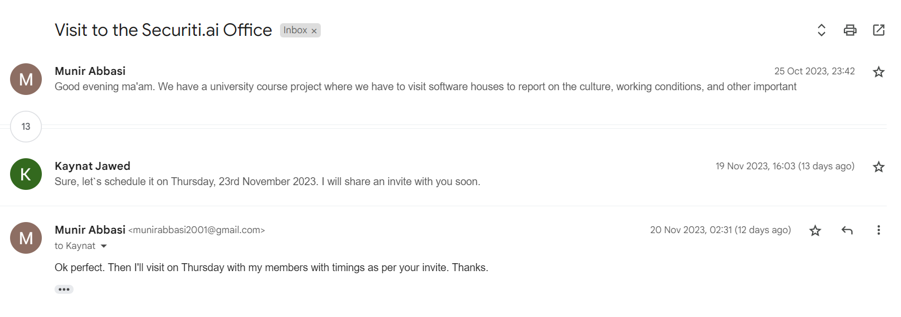

## **Interview processes.**

We went to both companies for the interviews and physically met with the developers. We were able to question the developers freely and ask them our questions.

# **Key Findings.**

As per the questions we got several responses from both of the companies. Here we will discuss the responses of the employees and then compare them.

## **Securiti.ai.**

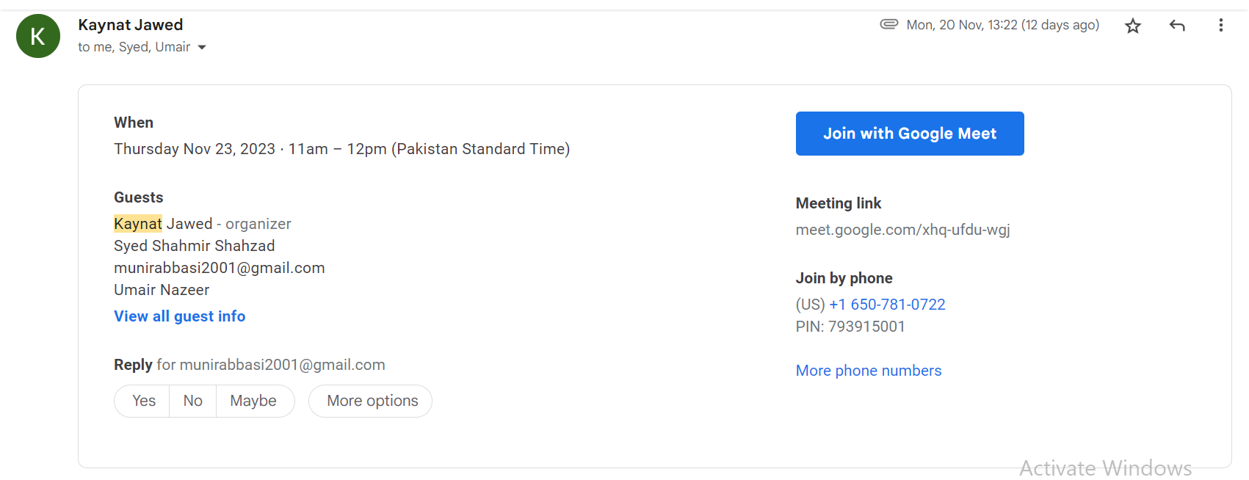

We interviewed Associate Software Engineer Shahmir Shahzad who was a recent graduate and gold medalist from the IBA class of 2019. We also had a senior developer Umair Nazeer who was the mentor of Shahmir.

### **Responses for the in-person interviews.**

Q1) The interviewers mentioned their code development process which included **standup meetings**. Day-to-day activities included coding, recreation, lunch, and prayer breaks.

Q2) The development environment was up to date with the trends. Umair bhai mentioned how he was **forced** to leave his previous jobs due to issues with **outdated** tech stacks. For the second part, the answer reflected the **people** over **processes** approach with the company. To ensure maximum collaboration, the company utilizes **ticketing** **software** like JIRA alongside Slack which ensures teams can work together.

Q3) The development processes included mostly **agile** and **iterative** approaches. The task allocation is very interesting. A very comprehensive top-down approach is followed.

When new **deliverables** for an environment are required, a **meeting** is held where the **availability** of employees is discussed, then modules are divided amongst the developers with the **load balanced** equally. It is a very **collaborative** environment which ensures that the developers and the technical leads all collaborate to complete deliverables while incorporating feedback.

Q4) The intra-country and cross-border collaboration is ensured with dedicated **communication** **channels** with the slack channels. This even helps in general communications with employees all over the world. It promotes **diversity** and **inclusivity**.  
  
Q5) A unique approach followed by the employees was employing principles of **Extreme Programming** (an approach for coding) which included code reviews of the employees among the developers which improves **code** **quality** and **code** **learnability** for people in the department. To ensure quality control, a QA department handles all quality metrics.

Q6) The employees lit up while answering the question. Umair bhai explained how the company would **sponsor** the Master's education for their employees. Additionally, the company is always improving and updating the tech stack. Securiti.ai introduced **AWS certifications** for employees and **neo4js** **certifications** for free for their employees.

Q7) The challenges faced by the developers were work-related like more software based. They could not highlight any issues such as office politics, unprofessional environments, and dissatisfaction.

Q8) They gave an example of a recent problem, however. There was an issue with the employees wanting to have a **space** to pray in the congregation, so a new **prayer** **area** was developed for the employees.

They also did **exchange programs** for the employees. This is where employees from the Karachi office would go to the Islamabad office and vice versa. This way teams would meet as well and have a good feedback and improvement process. This helped in **team building** and **recreation**.

Q9) The company followed a **Hybrid model** for the developers. Yes, the **flexibility** was where the employees were told that in case of **emergencies,** the employees had procedures in place. But there are also times when they have to work overtime for which the company takes good care of the employees which is why employees take ownership.

Q10) The employees had a very clear view of the direction of the future technologies and goals. The company has been grooming them as well; the company ensures that **certifications** and **training sessions** for technology are arranged and teams are also sent to attend **events** that relate to technologies.

### **Responses to the questionnaires.**

* Umair bhai had experience working at companies such as Avanza. He mentioned how Securiti.ai provided more development opportunities in his career.
* Umair bhai vehemently opposed this view. He explained how companies solve issues with a bottom-up approach and for that HR is very important and plays a crucial role.
* The prayer example was quoted previously. Similarly, the employees have asked HR for a gym facility and their requests have been acknowledged.
* In the improvements part, Shahmir bhai said that one change he would like to see is a go-green drive in the company.
* Both developers knew the CEO. They mentioned how they have annual events with the CEO. Mr. Rehan himself visits each office, addresses the employees, provides future directions, and even spends a week in the offices to monitor the facilities. They outlined how the CEO is also technically sound so the policies developed from up are already highly optimized for developers.

## **ONE Technology Services, USA**

The profile of the company was such that it was a company that receives outsourced projects that they develop and then maintain.

Here we were able to interview two of the seniors of our university. One was a graduate of the 17K batch, Siddhat Kumar (Senior .Net Developer). Another was M. Ahsan Khan, who graduated this year (2023), and currently is an Associate Software Engineer.

### **Responses for the in-person interviews.**

Q1) The day-to-day activities mentioned were like every other developer. The responsibilities he listed, however, included multiple roles which are generally different job roles.

Q2) The programming languages used were PHP/C#/.Net which are relatively old technologies. The development environment was a little bureaucratic. He stated how every change must be **approved** instead of pushed onto a **codebase**. Even senior engineers were not allowed to merge if their work was pending.

Q3) The development cycle was more based on the **waterfall** methodology. This is an old type approach but it is used due to the strict **quality** **control** for most of their projects which are based on legacy systems. There was **no** **particular** task allocation, the developer mentioned how the tasks are directly assigned to the **team**, and how they have to develop plans **themselves**.

Q4) The **developers** worked together in the office. They mostly communicate using **Microsoft Teams** and email.

Q5) The code review and quality control are managed by the **managers**. You would not expect the managers to manage these products themselves but rather have a separate QA environment.

Q6) The **developers** said there are not a lot of development and training programs because the company does not seem keen on **innovation**. The developers have to **learn** and **implement** new things by themselves.

Q7) The developers mentioned how there are issues at times with resource **allocation**. Sometimes; certain projects require more resources especially **front-end developers** due to project requirements. However, they have to manage it **themselves** since the company expects them to fulfil project requirements.

Q8) The developers mentioned how the feedback implementation is a **little** slow and **bureaucratic**. The developers mentioned that the company focuses mostly on the **processes** and tries to ensure **strict** measures that the employees adhere to traditional processes. Change is not welcome.

Q9) The **work-life** balance for the employees is very **unpredictable**. They mentioned how there may be a sudden surge in the **deliverables** which can lead to extra **working hours** for the developers. The flexibility is present but there are **no paid leaves** for the developers.

Q10) The employees were **unaware** of the **future directions** and stated that they expect the process to stay the same.

### **Responses to the questionnaires.**

* The developers have been employed at the companies for almost half a decade. They stated they don’t have experience elsewhere.
* The developer’s initial response was a slight chuckle. They stated they would like to skip this question.
* They highlighted that once the employees were in dire need of funds for surgery; without any hesitation, the company arranged the required.
* For improvements they said it would be better if the company focused on people over processes, improved the tech stack, and introduced innovation.
* The employees said they never met the CEO. They rated the policy decisions as good for the employee compensations and perks but hoped to see better working environments.

# **Conclusion.**

## 

**5.1 Summary of Findings**

Based on the in-person interviews and questionnaire responses, we found several key differences between Securiti.ai and One Technology Services USA relating to development processes, environments, training, work culture and employee engagement.

Securiti.ai utilizes modern technologies and agile methodologies, promotes collaboration, invests in ongoing training, offers good work-life balance and has high employee morale. Developers feel ownership in the organization's success and are empowered in technical decision-making.

In contrast, One Technology Services USA relies more on legacy systems, dated technologies and bureaucratic waterfall processes. There are fewer growth opportunities, unpredictable work demands, and employees feel disconnected from leadership. Processes are rigid and changes face resistance.

**5.2 Contributions to Existing Knowledge**

This comparative case study highlights best practices such as agile processes, collaborative culture and employee empowerment that directly correlate to developer productivity, innovation and job satisfaction. It provides insights for organizations seeking to transform legacy environments or boost employee retention.

Our findings also showcase the need for improved capacity planning and project resourcing practices to facilitate better work-life balance. Flexible work policies additionally support employee well-being.

**5.3 Limitations and Areas for Future Research**

As this study examined only two organizations, the findings cannot be generalized. Further research across more companies can reinforce the validity. Surveying developer sentiment on a larger scale could also yield additional quantitative data.

Longitudinal data tracking transformations sparked from this analysis could reveal long term business and cultural impact. As technology and work practices continue evolving quickly, updated research will be required.

# **Recommendations.**

Recommendations are being given after considering both the in-person interviews and the responses to questionaries received from the developers of the respective software houses.

**Modernize Technology**

* Adopt newer languages like JavaScript, Python, Java, and Go rather than ageing ones like PHP, C#, .NET. This aids innovation and hiring.
* Promote the culture of exploring and utilizing the value of Open Source stacks, frameworks and libraries.

**Streamline Processes**

* Reduce bureaucratic approvals, embrace agile methodologies, and implement project management tools like JIRA, Notion or Trello to track work. This accelerates development.

**Promote Collaboration**

* Encourage knowledge sharing through code reviews, tech talks, and mentorship programs. Foster team bonding via activities like office exchanges. This builds connections.

**Enable Professional Development**

* Sponsor conferences, workshops, training programs and certifications to keep skills current. This aids retention.

**Improve Work-Life Balance**

* Offer flexible and hybrid work options and generous time off policies. This reduces employee burnout and improves well-being.

**Set Technology Vision**

* Define a 3-5 year roadmap, and proactively upskill employees on strategic capabilities needed to execute that vision.

**Listen to Developer Feedback**

* Implement improvements quickly to address developer pain points around tools, processes, etc. This increases morale.

**Strengthen Capacity Planning**

* Carefully evaluate project resourcing needs to avoid understaffing. Build in buffers to handle uncertainty.

**Foster Inclusive Culture**

* Ensure developers feel welcomed, valued, and supported regardless of gender, ethnicity, orientation etc. Celebrate diversity.

**Empower Developers**

* Allow developers to self-organize around solving problems, and give them authority in making technical decisions. Reduce top-down directives.